* The possible interfaces are with performance on the basis of quality ??
* What kind of demand do we want ?
* What kind of loading do we prefer?
* Make use of the sub-subsystems: scheduling, loading, monitoring and control and sequencing
  + For sequencing make a table with all processing times to figure out the sequencing method in matlab. Define priorities.
  + For loading, calculate the OEE. Should we include workers? Link to performance subsystem?
  + Decide on a scheduling method and optimize schedule
  + For monitoring and control, what to do when getting behind planning. Also look at capacity and demand.(less important in our case because well defined demand)
* New machinery after schedule is figured out
* Define interfaces with other subsystems
* Inventory management?

Display a table with how we can load

Load:

How many machines do we need and the processing times

Given information:-Boundaries

Available production time : 2 shifts/day, 48 weeks/year-

Total available time for the new system is

Additional parts construction elements of the crane :

25 cranes per month so I crane has

Actions points:

* Choose two scheduling methods and compare the two. → explain briefly why other methods are not used

Types of sequencing:

* Customer priority: allows an important or aggrieved customer, or item, to be ‘processed’ prior to others, irrespective of the order of arrival of the customer or item
  + Customer priority sequencing, although giving a high level of service to some customers, may erode the service given to many others. This may lower the overall performance of the operation if work flows are disrupted to accommodate important customers.
* Due date (DD): Prioritizing by due date means that work is sequenced according to when it is ‘due’ for delivery, irrespective of the size of each job or the importance of each customer
  + Due date sequencing usually improves the delivery dependability and average delivery speed. It may not provide optimal productivity, as a more efficient sequencing of work may reduce total costs.
* Last In First Out (LIFO)
* First In First Out (FIFO)
  + Easy to apply. Also, fair to customers, ethically accepted as the one who is waiting the longest, will be served first.
* Longest operation time (LOT): Operations may feel obliged to sequence their longest jobs first
  + Occupying work centers for long periods→ High utilization. However, may work against delivery speed, reliability or flexibility
* Shortest operation time first (SOT): Tackle short operations first
  + Improving delivery performance, if the unit of measurement of delivery is jobs. However, it may adversely affect total productivity and can damage service to larger customers.
* For sequencing, we make a table (Using matlab). For this, a decision has to be made if we use backward or forward sequencing.

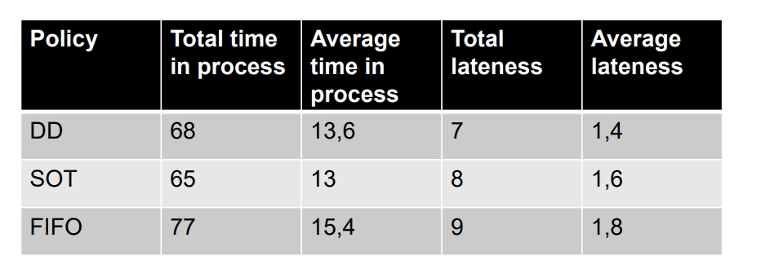

* Loading → finite or infinite. We tend to use infinite, however it depends on the sequencing method chosen

Finite loading -allocating work to a work center or a group of people upto a set limit. In our case, let’s say workers have a fixed 9-5 job, or a 36-40 hour working week. → planning is harder, because we have fixed time slots. However, it may take longer to finish all planned products. Unfinished work has to be planned together with the already planned work.

Infinite loading- in this type there is no limit accepting work but it instead tries to cope with it. In our case, workers are allocated to a certain amount of products per time unit. They have to finish this, even though it exceeds their normal working hours (overtime). This increases ease of planning, as it can be done per time unit without delay. Also, total production time is reduced.

See figure underneath for visual representation

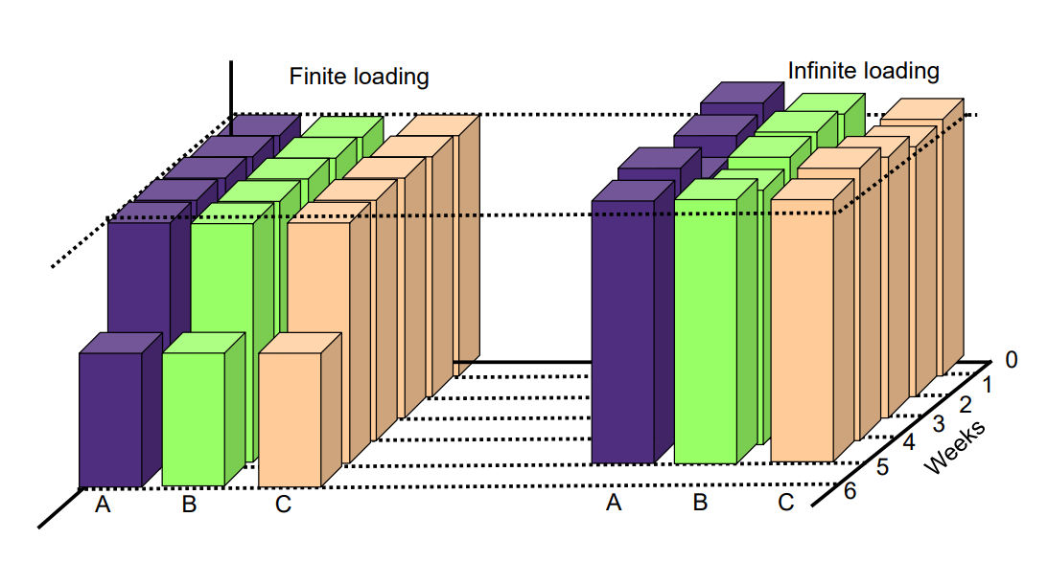

* Decide work load. We need to use as many ‘old’ machines as possible to reach the ‘old’ production combined with the new STS cranes. Optimize to buy as few new machines as possible.
* For control; determine if we use pull or push philosophy. This depends on the scheduling method we use.

Pull control is a system whereby demand is triggered by requests from a work center’s (internal) customer

Push control is a centralized system whereby control (and sometimes planning) decisions are issued to work centers which are then required to perform the task and supply the next workstation.

In manufacturing, ‘pull’ schedules generally have far lower inventory levels than ‘push’ schedules.

* Show calculations to get the OEE. This should be 95% at least.
* Ask Wieteke to what extent we need to include man hours? Combining the old and new production, how much time do we need and do we take into account only machines? Or to what extent do we include workers?

**Loading(CHECK DATA SHEET LOADING)**

Loading table template- Processing time per machine per production line for 4 months

| Production lines | SM (hrs) | TM  (hrs) | GM  (hrs) | CMM  (hrs) | MM  (hrs) | DM  (hrs) | MC  (hrs) | A  (hrs) | CM  (hrs) |
| --- | --- | --- | --- | --- | --- | --- | --- | --- | --- |
| 1 | 368.54 | 317.74 | 383.4 | 700.85 | 383.4 | 0 | 0 | 748.79 | 0 |
| 2 | 0 | 0 | 517.83 | 748.73 | 0 | 0 | 441.26 | 346.62 | 0 |
| 3 | 163.34 | 0 | 0 | 0 | 138.48 | 107.05 | 0 | 0 | 166.3 |
| 4 | 256.9 | 0 | 151.94 | 393.54 | 0 | 0 | 584.4 | 370.46 | 0 |
| 5 | 280.01 | 350.146 | 490.7 | 206.36 | 250.71 | 298.8 | 0 | 440.9 | 0 |
| 6 | 0 | 120.65 | 209.7 | 31.6 | 133.1 | 0 | 0 | 0 | 0 |

Set up times + idle time for each production line

| Production lines | SM | TM | GM | CMM | MM | DM | MC | A | CM |
| --- | --- | --- | --- | --- | --- | --- | --- | --- | --- |
| 1 |  |  |  |  |  |  |  |  |  |
| 2 |  |  |  |  |  |  |  |  |  |
| 3 |  |  |  |  |  |  |  |  |  |
| 4 |  |  |  |  |  |  |  |  |  |
| 5 |  |  |  |  |  |  |  |  |  |
| 6 |  |  |  |  |  |  |  |  |  |

**Sequencing**

|  | *Total*  *Lateness (Production days)* | *Average Lateness*  *(Production days)* | *Process time*  *(Production days)* | *Average time in process*  *(Production days)* |
| --- | --- | --- | --- | --- |
| **Line 1** | 239 | 1.96 | 6391.5 | 56.4 |
| **Line 2** | 7 | 0.10 | 3027.0 | 43.9 |
| **Line 3** | 0 | 0 | 574.1 | 31.9 |
| **Line 4** | 0 | 0 | 2228.6 | 43.7 |

Line 1 has quite a high lateness. This is caused by the large amount of orders with a due date in the beginning of august. The machine which mainly causes this problem is the assembly table. In the end, everything is still finished in the predetermined four month period. This lateness can be reduced by adding another assembly table to the now two assembly tables. This will increase the cost and the time where the assembly tables are not used but significantly decreases the total lateness to 7 days with a average of 0.057